World Rally Championship 2002
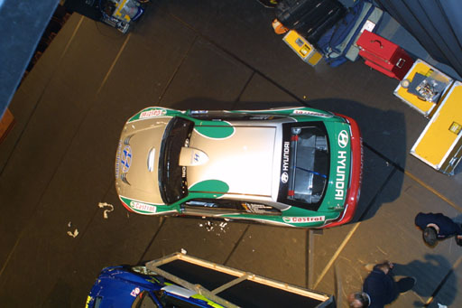  top photograph |  | 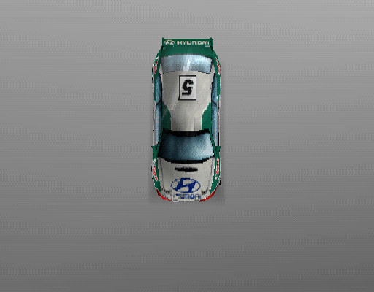  top game image
comments |  | comments
Team : HYUNDAI  Format : PSone  Submission no: 2  Date : 19th April 2002 | Submitted by : Jo Richardson  WRC Collateral Manager, SCEE  contact details  tel : 0151 282 3540  fax : 0151 282 3353 | Artwork use  in game models [ X ]  marketing/PR use [ X ] |  | 

World Rally Championship 2002
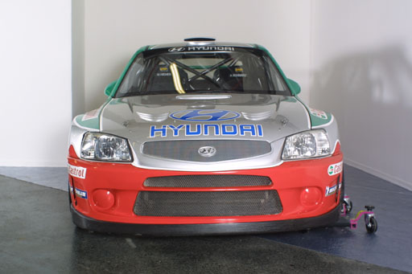  front photograph |  | 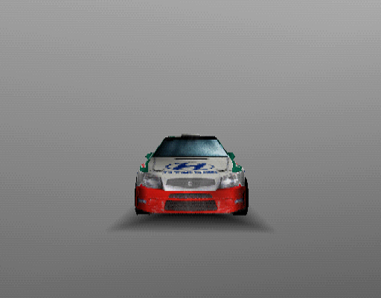  front game image
comments |  | comments
Team : HYUNDAI  Format : PSone  Submission no: 2  Date : 19th April 2002 | Submitted by : Jo Richardson  WRC Collateral Manager, SCEE  contact details  tel : 0151 282 3540  fax : 0151 282 3353 | Artwork use  in game models [ X ]  marketing/PR use [ X ]

World Rally Championship 2002
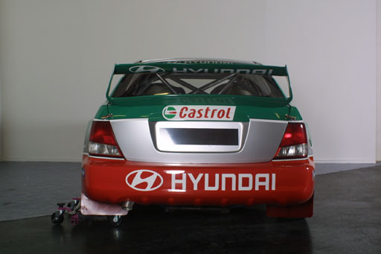  back photograph |  | 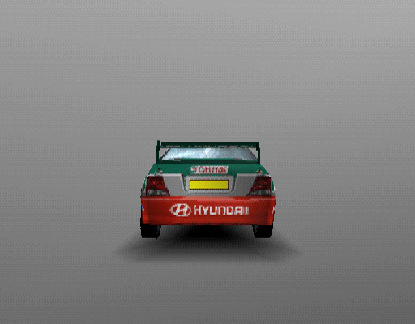  back game image
comments |  | comments
Team : HYUNDAI  Format : PSone  Submission no: 2  Date : 19th April 2002 | Submitted by : Jo Richardson  WRC Collateral Manager, SCEE  contact details  tel : 0151 282 3540  fax : 0151 282 3353 | Artwork use  in game models [ X ]  marketing/PR use [ X ]

World Rally Championship 2002
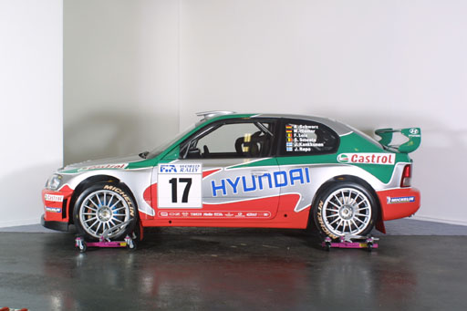  left photograph |  | 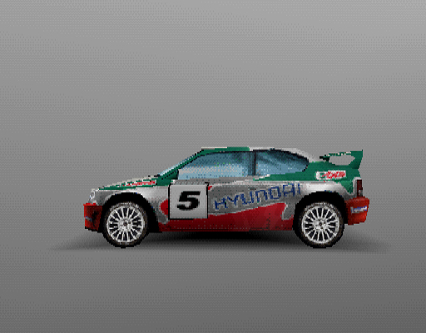  left game image
comments |  | comments
Team : HYUNDAI  Format : PSone  Submission no: 2  Date : 19th April 2002 | Submitted by : Jo Richardson  WRC Collateral Manager, SCEE  contact details  tel : 0151 282 3540  fax : 0151 282 3353 | Artwork use  in game models [ X ]  marketing/PR use [ X ]

World Rally Championship 2002
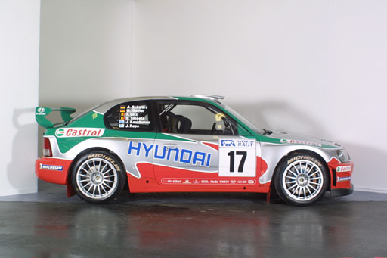  right photograph |  | 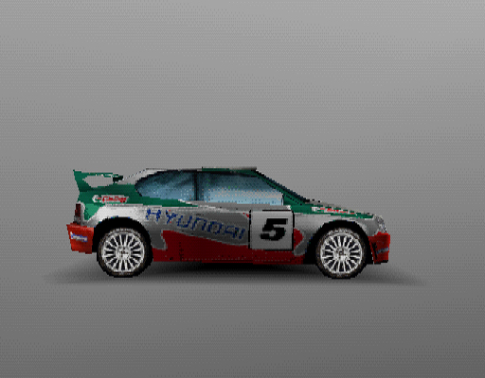  right game image
comments |  | comments
Team : HYUNDAI  Format : PSone  Submission no: 2  Date : 19th April 2002 | Submitted by : Jo Richardson  WRC Collateral Manager, SCEE  contact details  tel : 0151 282 3540  fax : 0151 282 3353 | Artwork use  in game models [ X ]  marketing/PR use [ X ]

